SUMMARY
In the given data set, there are 4 spread sheets illustrates
- PRODUCT_DIM
- CUSTOMER_DIM
- STORE_DIM
- SALES_FACT
For every data sheets tables are created.
STEP 1:
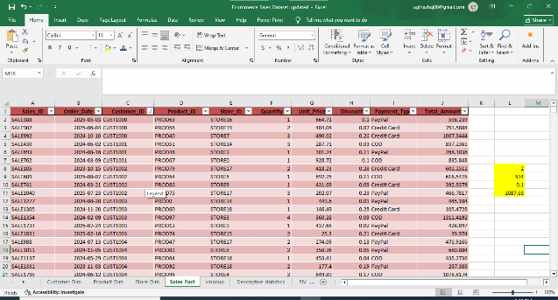
DATA CLEANING
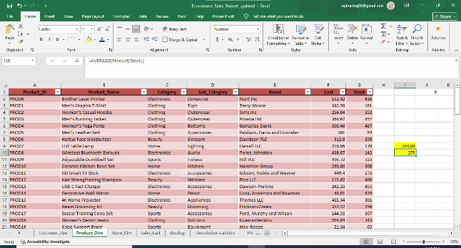
- In customer table errors in “customer Id” and “Country” are corrected through Find and Replace
- In Product table using AVERAGE formula missing items in “cost” and “stock” are find and replaced.
- In Sales table using MODE formula missing items of both “Quantity” and “Discount” and using AVERAGE formula “Unit price and “Total amount” are find and replaced.

STEP 2:
VLOOKUP
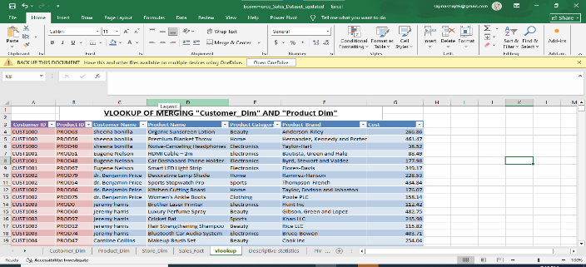

Using “VLOOKUP” Function “Product” and “Customer” table are combined by extracting specific data column according to costumer id numerical order like product name,brand,category and cost.

STEP 3:
DESCRIPTIVE STATISTICS:
Using “Analysis Toolpak” summary of total number of sales are calculated.
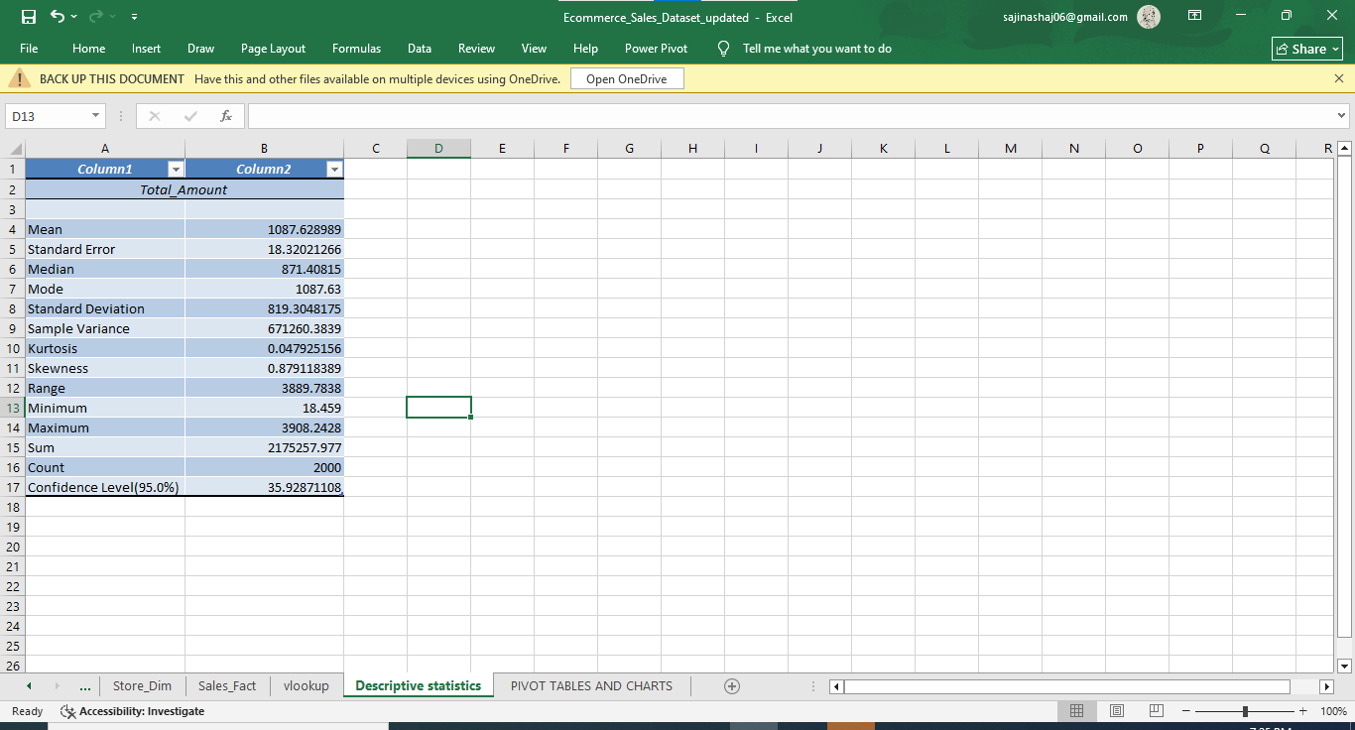

STEP 4:
PIVOT TABLE
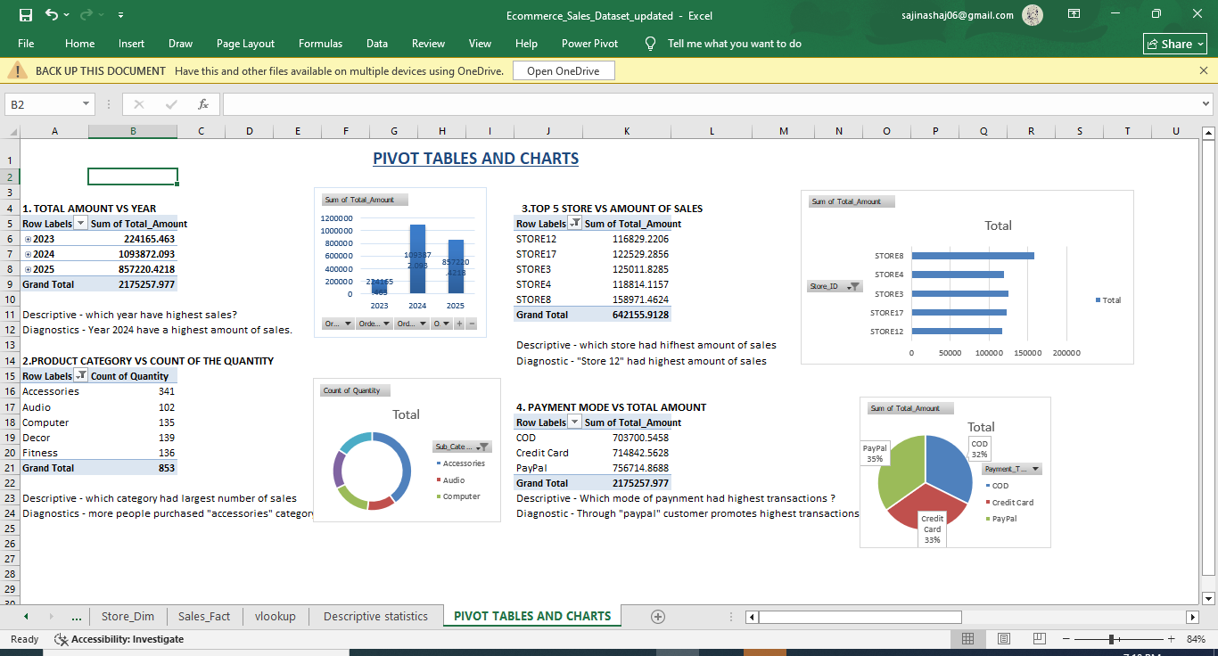
- Using “DATA MODELLING” in data tab tables are combined with Sales table as main table.
- Now inserting “PIVOT TABLE” created different types of pivot tables and values.

STEP 5: CREATING DASHBOARDS:
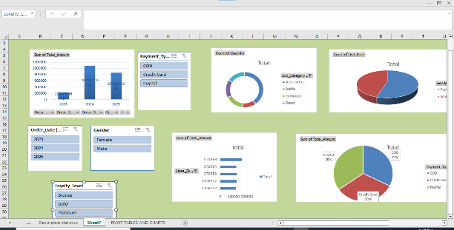

Using “SLICER” Option in insert tab more filter options are created regarding GENDER, YEAR AND LOYALTY LEVEL.
THANKYOU!

